**To: Rick Ales**

**From: Paul Mathews, Mathews Malnar and Bailey, Inc.**

**Date: 16 April 2025**

**Subject: Calibration and Gage Study of an Oil Depth Gage**

**Executive Summary**

A calibration and gage error study was performed to characterize the performance of the depth measurement of a mechanical oil gage relative to accepted reference values from a laser gage. The study showed that the depth measurement is a simple linear function of the laser value with no evidence for nonlinearity or Trial biases or slope effects. The slope between the mechanical measurement and the laser measurement is slightly biased away from the expected 1:1 relationship; however, that bias may be practically insignificant.

The random effect of Trials was used to estimate measurement reproducibility which was determined to be 0.0028 inches. The random noise in the measurements (i.e. repeatability) was determined to be 0.0037 inches. The combined reproducibility and repeatability variation is 0.0047 inches.

**Purpose**

The purpose of this report is to present the statistical analysis of at experiment to study the calibration and gage error performance of a measurement of fluid depth for an oil pressure level gage. The accepted reverence values (ARV) for the depth come from a laser gage and the mechanical measurement is performed by a depth gage.

**Experimental Data**

The experimental data were provided by Rick Ales in Excel file *CAL_Level_RnR_241105.xlsx* and are presented in Table 1.

* The Operator who collected the data is shown in column *Op* and the dates when the data were collected are shown in column *DateTime*.
* Columns *Op* and *DateTime* were combined into a composite column named *Trial* that will be used as the source of reproducibility variation.
* The *SetPoint* values are the target oil depths as triggered by the laser measurements in column *Laser*. The laser measurement is used to shut down the oil fill when the laser measurement is within 0002” of the target.
* Column *Index* (1 to 5) is just the ID number of the setpoints.
* The mechanical depth gage measurements are reported in column *Measure*.
* Column *Error* is the difference between the *Laser* measurement and the *SetPoint* value.

**Statistical Analysis**

All graphical and statistical analyses were performed using MINITAB V22.2.2 and are recorded in MINITAB file *Oil Depth Gage 20250416.mpx*.

Figure 1 shows the plot of setpoint errors (*Laser* minus *SetPoint*) by *Index*. The errors are spread uniformly above and below the horizontal reference line / target at *Error* = 0. Figure 2 shows that the *Error* values are approximately normally distributed with unusually high densities of points around *Error* = 0 and 0.050. From the inset table in Figure 2 the setpoint mean is 0.009 inches – very close to the target value (0) – and the standard deviation is 0.030 inches – quite a bit larger than the 0.002 inch window used to turn off the pump.

Figure 3 shows the scatterplot of *Measure* as a function of *Laser* and *Trial*. *Measure* appears to be a simple linear function of *Laser* with minimal biases or slope effects from *Trial*.

Figure 4 shows the ANOVA model for of *Measure* as a function of *Laser* and *Trial*. *Laser* was included in the model as a continuous covariate and *Trial* was included as a random qualitative factor. The quadratic term for *Laser* and the *Laser*Trial* interaction were also included in the model.

The model shows that:

* The *Laser2* term is not statistically significant (p = 0.713) which indicates that *Measure* is a simple linear function of *Laser*.
* The *Laser*Trial* term is not statistically significant (p = 0.993) which indicates that the slope of *Measurement* versus *Laser* is homogeneous across *Trials*.
* The *Trial* term is not statistically significant (p = 0.215) which indicates that the standard deviation of the random biases between trials is not different from zero.

In conclusion, the *Measure* response is a simple linear function of *Laser* with no indication of nonlinearities or *Trial* effects. The **Coefficients** table indicates that the best fit line to the data is

$$Measure=9.599-0.9964×Laser$$

The standard errors of the y-axis intercept and slope coefficients are 0.0026 and 0.0015, respectively. The slope coefficient can be tested to see if it differs from its expected value -1.0 using Student’s t test. The test’s t statistic is

$$t=\frac{-0.9964-1.0}{0.0015}=2.45$$

which is statistically significant (p = 0.025), so the slope is biased slightly from its target value.

The **Variance Components** table at the end of the ANOVA report indicates that the standard deviation of biases between trials is 0.0028 inches. This value quantifies the measurement reproducibility with respect to trials. The standard deviation of the residuals/error is 0.0037 inches which quantifies the measurement repeatability. The combined standard deviation from both random sources of noise is 0.0047 which quantifies the combined gage error due to reproducibility and repeatability sources.

The residuals diagnostic plots in Figure 5 show that the residuals are normal and homoscedastic as required by the ANOVA method.

**Table 1. Experimental data.**

|  |  |  |  |  |  |  |  |  |
| --- | --- | --- | --- | --- | --- | --- | --- | --- |
| **Row** | **Op** | **DateTime** | **Trial** | **Index** | **Set Point** | **Laser** | **Measure** | **Error** |
| 1 | Dragan | 11/6/24 13:17 | 1 | 1 | 1.100 | 1.102 | 8.495 | 0.002 |
| 2 | Dragan | 11/6/24 13:17 | 1 | 2 | 2.700 | 2.664 | 6.938 | -0.036 |
| 3 | Dragan | 11/6/24 13:17 | 1 | 3 | 4.300 | 4.260 | 5.347 | -0.040 |
| 4 | Dragan | 11/6/24 13:17 | 1 | 4 | 5.800 | 5.756 | 3.857 | -0.044 |
| 5 | Dragan | 11/6/24 13:17 | 1 | 5 | 7.200 | 7.249 | 2.374 | 0.049 |
| 6 | George | 11/6/24 13:27 | 2 | 1 | 1.100 | 1.102 | 8.499 | 0.002 |
| 7 | George | 11/6/24 13:27 | 2 | 2 | 2.700 | 2.735 | 6.876 | 0.035 |
| 8 | George | 11/6/24 13:27 | 2 | 3 | 4.200 | 4.188 | 5.417 | -0.012 |
| 9 | George | 11/6/24 13:27 | 2 | 4 | 5.800 | 5.793 | 3.822 | -0.007 |
| 10 | George | 11/6/24 13:27 | 2 | 5 | 7.200 | 7.248 | 2.384 | 0.048 |
| 11 | Dragan | 11/6/24 13:40 | 3 | 1 | 1.100 | 1.102 | 8.500 | 0.002 |
| 12 | Dragan | 11/6/24 13:40 | 3 | 2 | 2.700 | 2.722 | 6.897 | 0.022 |
| 13 | Dragan | 11/6/24 13:40 | 3 | 3 | 4.200 | 4.213 | 5.406 | 0.013 |
| 14 | Dragan | 11/6/24 13:40 | 3 | 4 | 5.700 | 5.738 | 3.888 | 0.038 |
| 15 | Dragan | 11/6/24 13:40 | 3 | 5 | 7.200 | 7.249 | 2.384 | 0.049 |
| 16 | George | 11/6/24 13:49 | 4 | 1 | 1.100 | 1.102 | 8.503 | 0.002 |
| 17 | George | 11/6/24 13:49 | 4 | 2 | 2.700 | 2.703 | 6.909 | 0.003 |
| 18 | George | 11/6/24 13:49 | 4 | 3 | 4.200 | 4.176 | 5.444 | -0.024 |
| 19 | George | 11/6/24 13:49 | 4 | 4 | 5.700 | 5.745 | 3.881 | 0.045 |
| 20 | George | 11/6/24 13:49 | 4 | 5 | 7.200 | 7.248 | 2.382 | 0.048 |
| 21 | Dragan | 11/6/24 13:59 | 5 | 1 | 1.100 | 1.102 | 8.504 | 0.002 |
| 22 | Dragan | 11/6/24 13:59 | 5 | 2 | 2.700 | 2.676 | 6.936 | -0.024 |
| 23 | Dragan | 11/6/24 13:59 | 5 | 3 | 4.200 | 4.178 | 5.442 | -0.022 |
| 24 | Dragan | 11/6/24 13:59 | 5 | 4 | 5.700 | 5.715 | 3.908 | 0.015 |
| 25 | Dragan | 11/6/24 13:59 | 5 | 5 | 7.200 | 7.249 | 2.381 | 0.049 |
| 26 | 8.504 | 11/6/24 14:09 | 6 | 1 | 1.100 | 1.101 | 8.504 | 0.001 |
| 27 | 8.504 | 11/6/24 14:09 | 6 | 2 | 2.700 | 2.707 | 6.907 | 0.007 |
| 28 | 8.504 | 11/6/24 14:09 | 6 | 3 | 4.200 | 4.183 | 5.439 | -0.017 |
| 29 | 8.504 | 11/6/24 14:09 | 6 | 4 | 5.700 | 5.716 | 3.906 | 0.016 |
| 30 | 8.504 | 11/6/24 14:09 | 6 | 5 | 7.200 | 7.249 | 2.383 | 0.049 |

**Figure 1. SetPoint Error.**

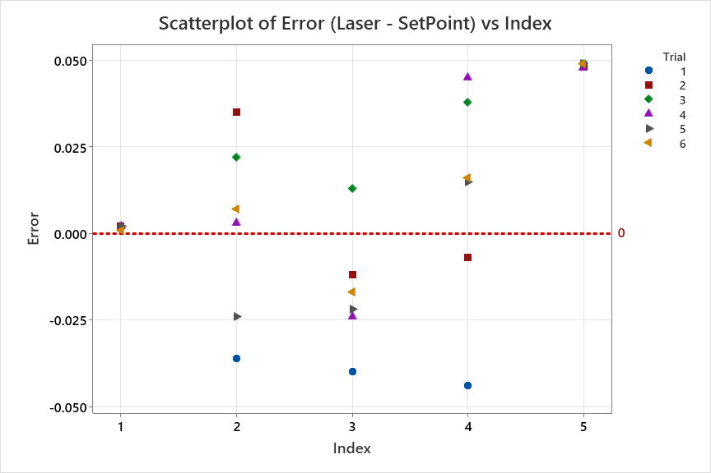

**Figure 2. Normal probability plot of SetPoint Error.**

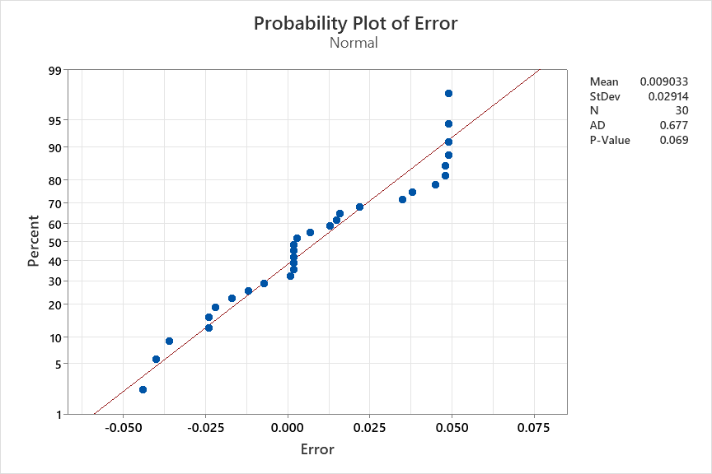

**Figure 3. Scatterplot of Measure = f(Laser, Trial).**

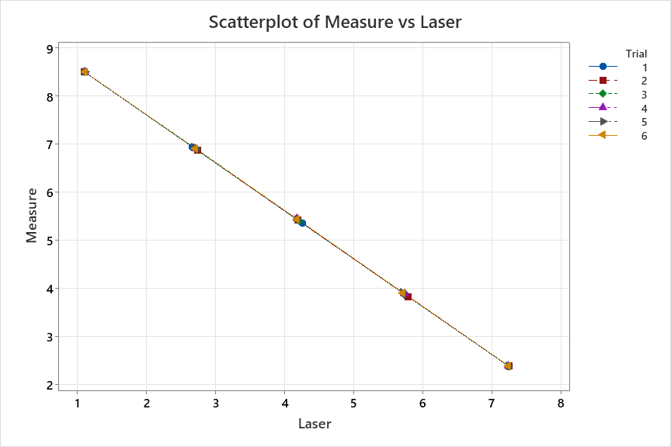

**Figure 4. ANOVA for Measure = f(Laser, Trial).**

WORKSHEET 1

**General Linear Model: Measure versus Laser, Trial**

**Factor Information**

|  |  |  |  |
| --- | --- | --- | --- |
| **Factor** | **Type** | **Levels** | **Values** |
| Trial | Random | 6 | 1, 2, 3, 4, 5, 6 |

**Analysis of Variance**

|  |  |  |  |  |  |
| --- | --- | --- | --- | --- | --- |
| **Source** | **DF** | **Adj SS** | **Adj MS** | **F-Value** | **P-Value** |
| Laser | 1 | 6.395 | 6.39548 | 462334.21 | 0.000 |
| Trial | 5 | 0.000 | 0.00002 | 1.60 | 0.215 |
| Laser*Laser | 1 | 0.000 | 0.00000 | 0.14 | 0.713 |
| Laser*Trial | 5 | 0.000 | 0.00000 | 0.09 | 0.993 |
| Error | 17 | 0.000 | 0.00001 |  |  |
| Total | 29 | 139.980 |  |  |  |

**Model Summary**

|  |  |  |  |
| --- | --- | --- | --- |
| **S** | **R-sq** | **R-sq(adj)** | **R-sq(pred)** |
| 0.0037193 | 100.00% | 100.00% | 100.00% |

**Coefficients**

|  |  |  |  |  |  |
| --- | --- | --- | --- | --- | --- |
| **Term** | **Coef** | **SE Coef** | **T-Value** | **P-Value** | **VIF** |
| Constant | 9.59946 | 0.00264 | 3639.27 | 0.000 |  |
| Laser | -0.99637 | 0.00147 | -679.95 | 0.000 | 21.91 |
| Trial |  |  |  |  |  |
| 1 | -0.00744 | 0.00331 | -2.25 | 0.038 | * |
| 2 | -0.00395 | 0.00331 | -1.19 | 0.249 | * |
| 3 | 0.00213 | 0.00331 | 0.64 | 0.530 | * |
| 4 | 0.00245 | 0.00331 | 0.74 | 0.470 | * |
| 5 | 0.00346 | 0.00330 | 1.05 | 0.310 | * |
| 6 | 0.00336 | 0.00331 | 1.02 | 0.324 | * |
| Laser*Laser | 0.000064 | 0.000171 | 0.37 | 0.713 | 21.91 |
| Laser*Trial |  |  |  |  |  |
| 1 | -0.000078 | 0.000698 | -0.11 | 0.913 | 7.87 |
| 2 | 0.000133 | 0.000699 | 0.19 | 0.851 | 7.91 |
| 3 | 0.000361 | 0.000701 | 0.52 | 0.613 | 7.92 |
| 4 | 0.000010 | 0.000700 | 0.01 | 0.989 | 7.89 |
| 5 | -0.000317 | 0.000700 | -0.45 | 0.657 | 7.88 |
| 6 | -0.000110 | 0.000701 | -0.16 | 0.877 | * |

**Fits and Diagnostics for Unusual Observations**

|  |  |  |  |  |  |
| --- | --- | --- | --- | --- | --- |
| **Obs** | **Measure** | **Fit** | **Resid** | **Std Resid** |  |
| 8 | 5.41700 | 5.42439 | -0.00739 | -2.29 | R |
| 10 | 2.38400 | 2.37814 | 0.00586 | 2.61 | R |

*R  Large residual*

**Variance Components, using Adjusted SS**

|  |  |  |  |  |
| --- | --- | --- | --- | --- |
| **Source** | **Variance** | **% of Total** | **StDev** | **% of Total** |
| Trial | 0.0000078 | 36.13% | 0.0027973 | 60.11% |
| Error | 0.0000138 | 63.87% | 0.0037193 | 79.92% |
| Total | 0.0000217 |  | 0.0046538 |  |

**Figure 5. Residuals diagnostic plots.**

